SeSSSSedsS and Sprouts`

**Seeds and Sprouts ELCC**

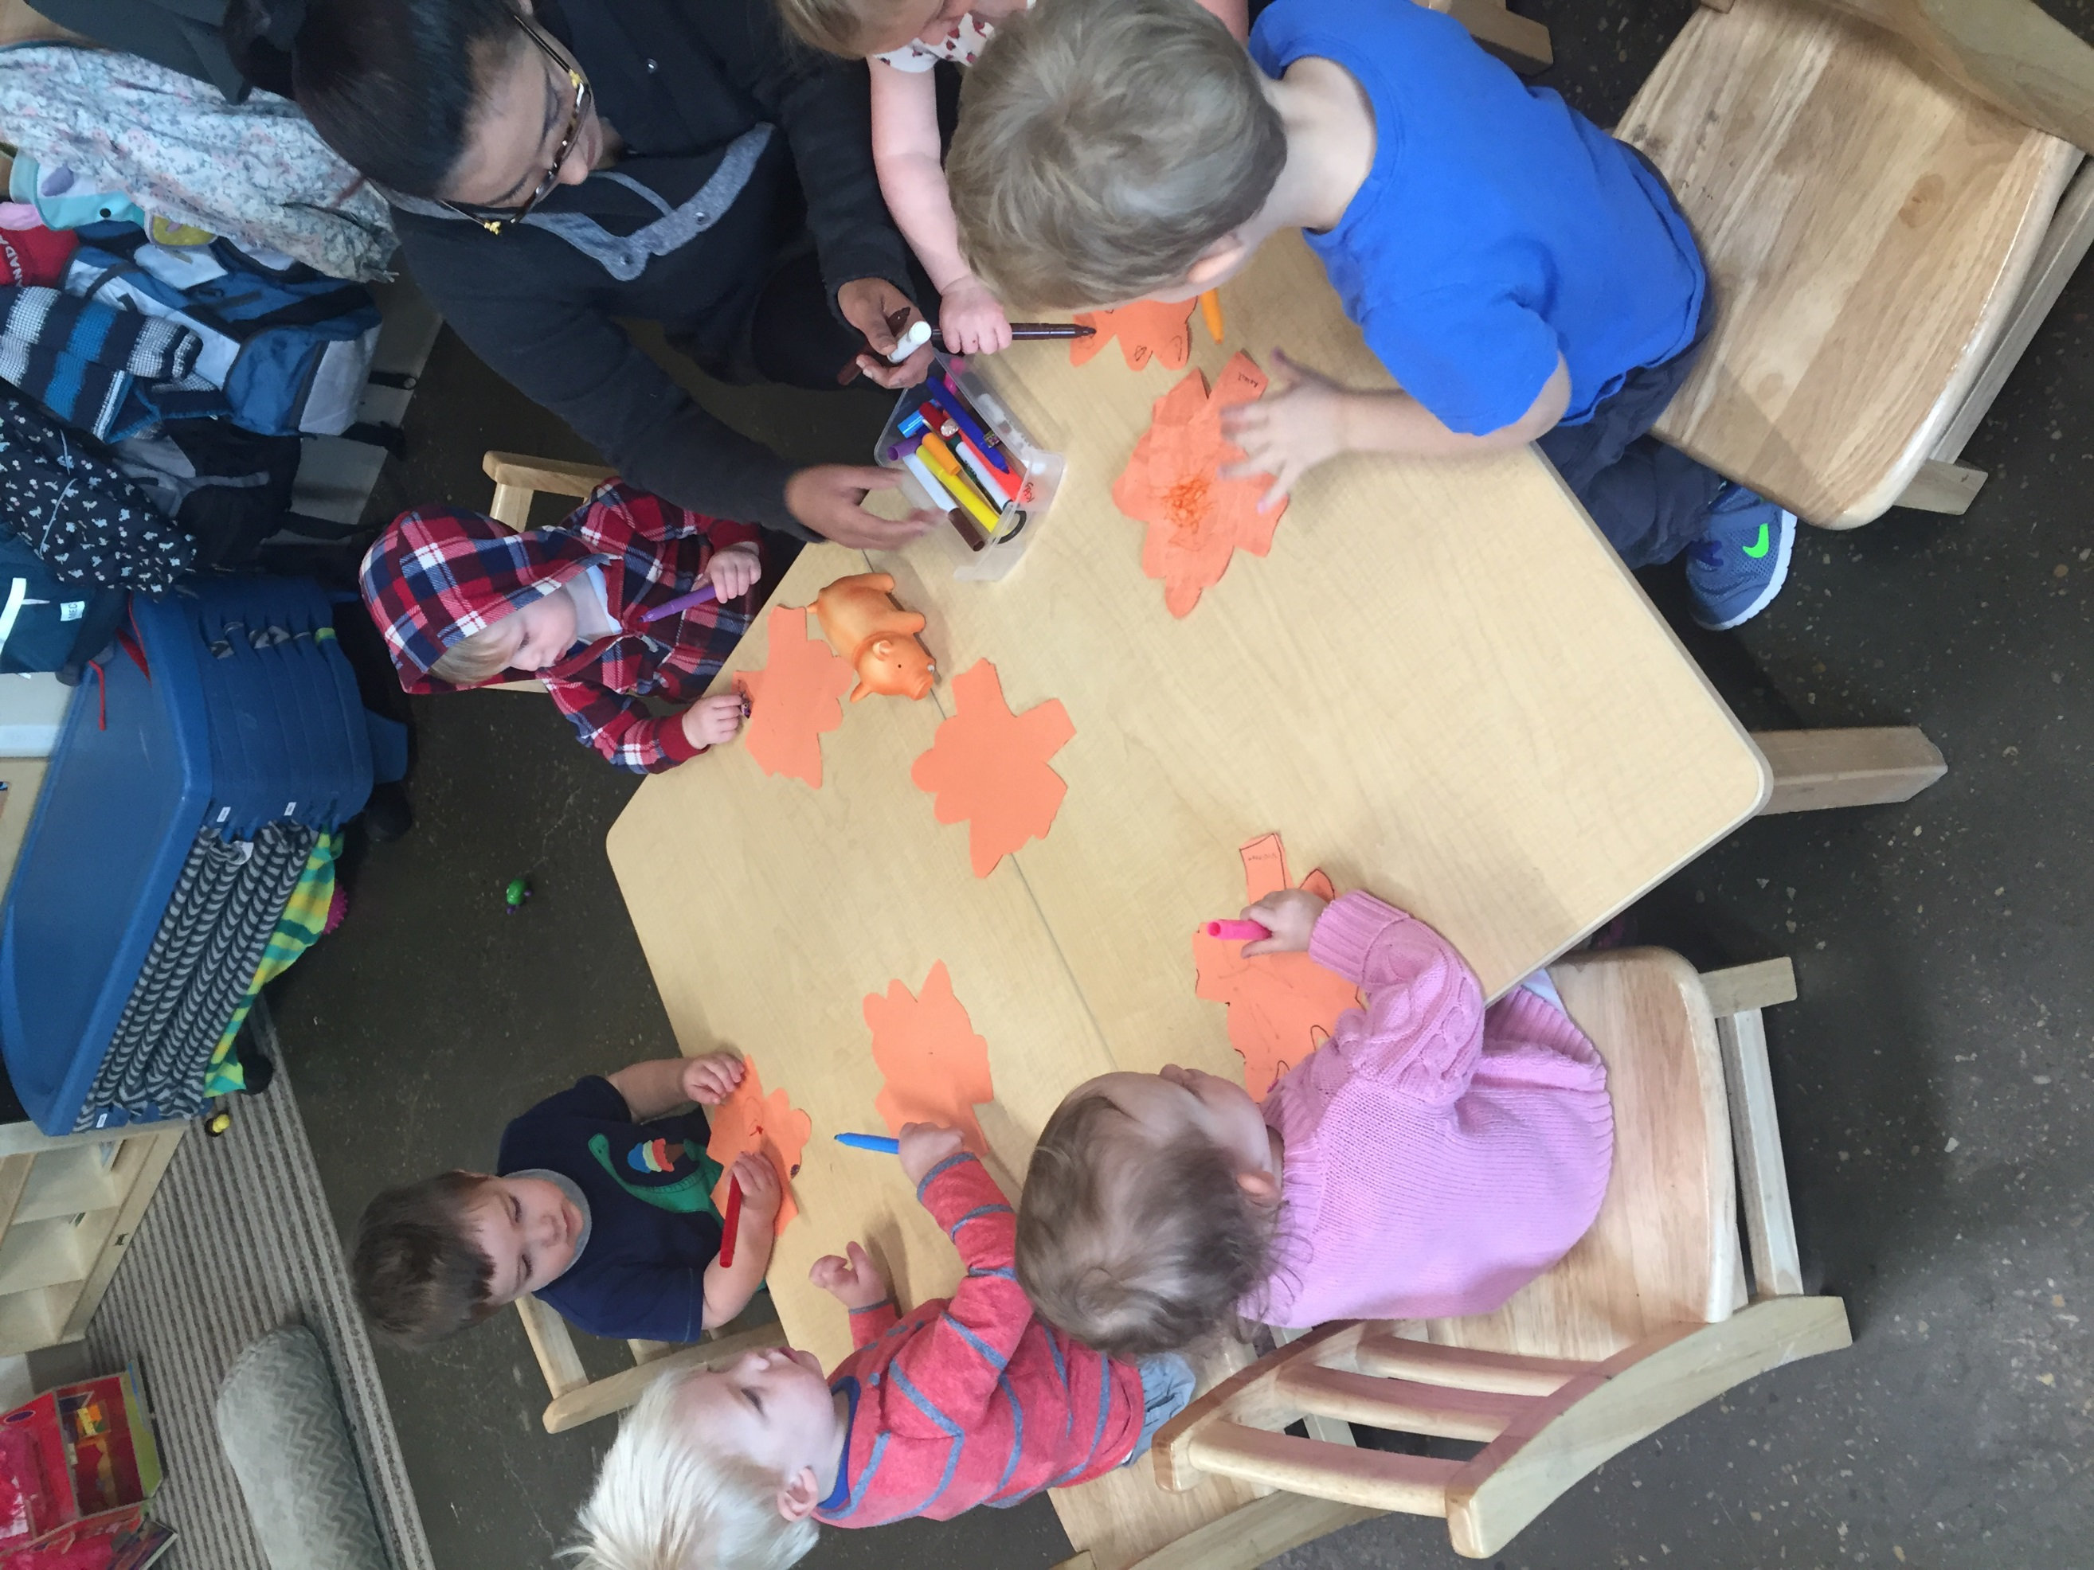

Programming:

The children interest is emerging into Fall. As you look around the room you can see many of the children’s crafts. We have been taking daily walks and looking at the leaves changing, collecting pinecones and adding them to their play in the room. Been doing experiments with the leaves watching them change colours and how they feel and sounds they make. You can see some videos and photos on our closed face book page.

Important Dates

Centre would be closed on Monday, October 9th for Thanksgiving – GOBBLE GOBBLE

On October 31, We'll be having a Halloween Party/Concert. We would like to invite the parents to attend our toddlers concert starting around 3:30ish please look at updates on the white board. Also don’t forget Fridays are special days you can see this posted on the door on the white board. We will also be trick or treating in the building to the local businesses.

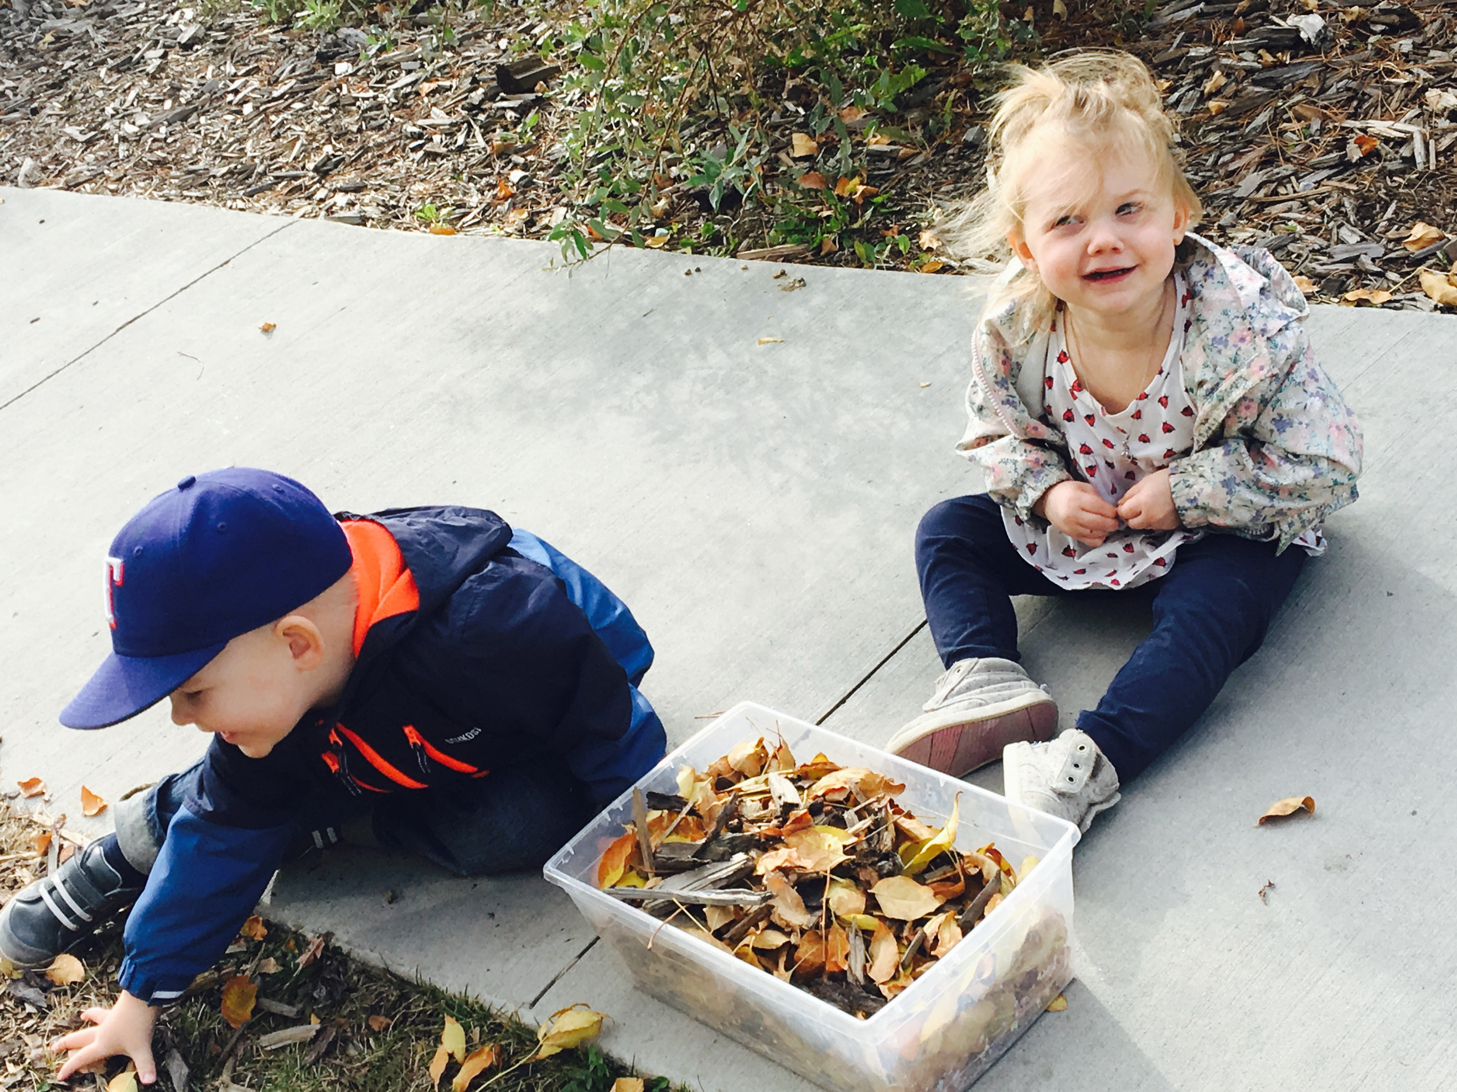

**GENTLE REMINDER**

Please ensure your child comes appropriately dressed for the weather e.g. coat, hat/toque and rain boots. Bundle up and enjoy the fresh air!

In the month of October we will be would Like to Welcome Our new friend Anthony.

***Newsletter October 2017***