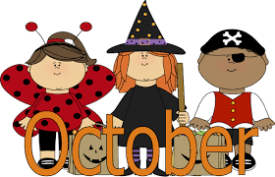

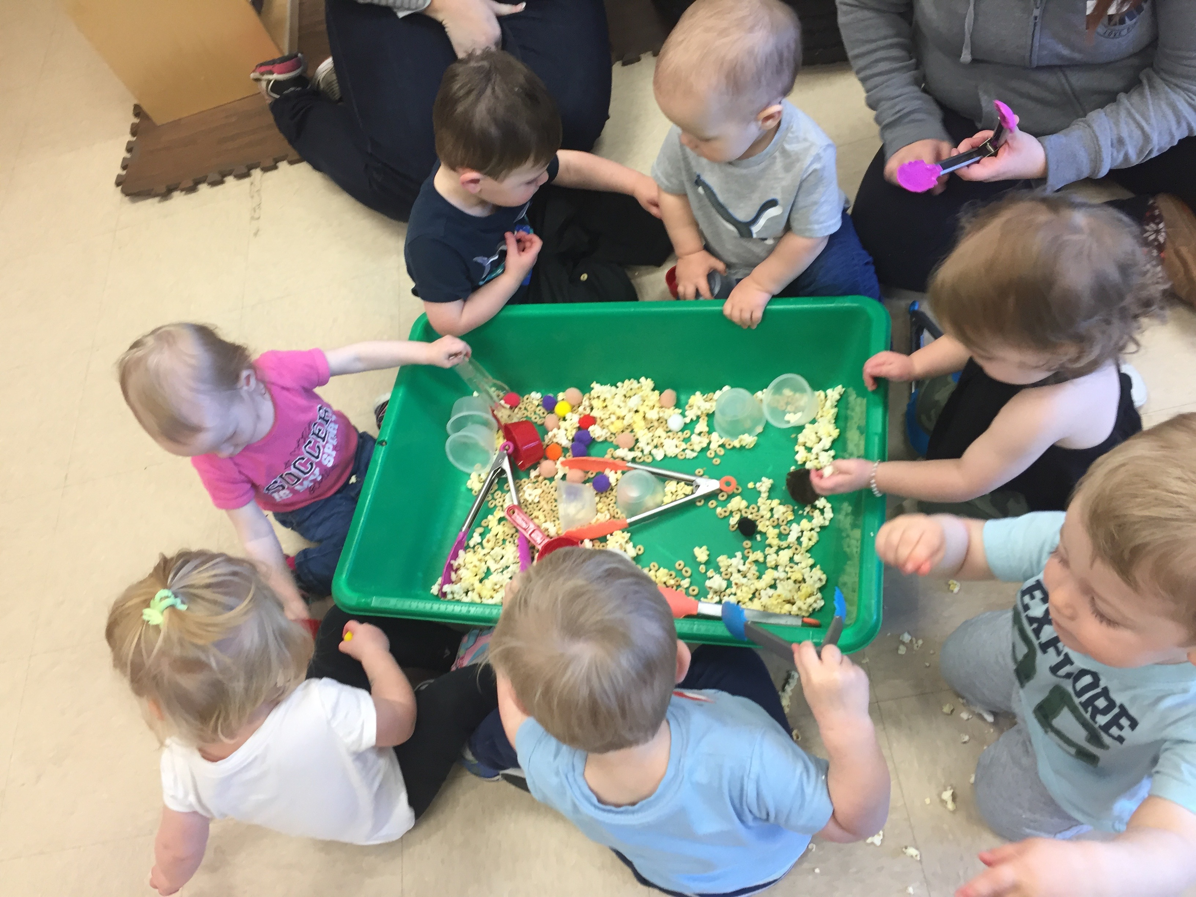
Dear all Nursery families,
As the temperatures continue to fall, please make sure your child has adequate outdoor clothing for the temperatures.
• Hats & mittens
• Snow boots
• Winter coat/winter jacket
• Snow pants
Children need fresh air and large motor exercise daily, please remember to have these items so that your child may be able to enjoy and participate in the fall/winter season with us. Please dress your child warm for cold weather. Also, make sure everything is labeled. Thanks!
Important reminders
• Please bring extra food when you order hot lunch for your child
• Kindly bring diapers especially when you receive a note to bring one, extra clothes and socks.
• Don’t forget to bring blanket every Monday and bring it home on Friday to be wash

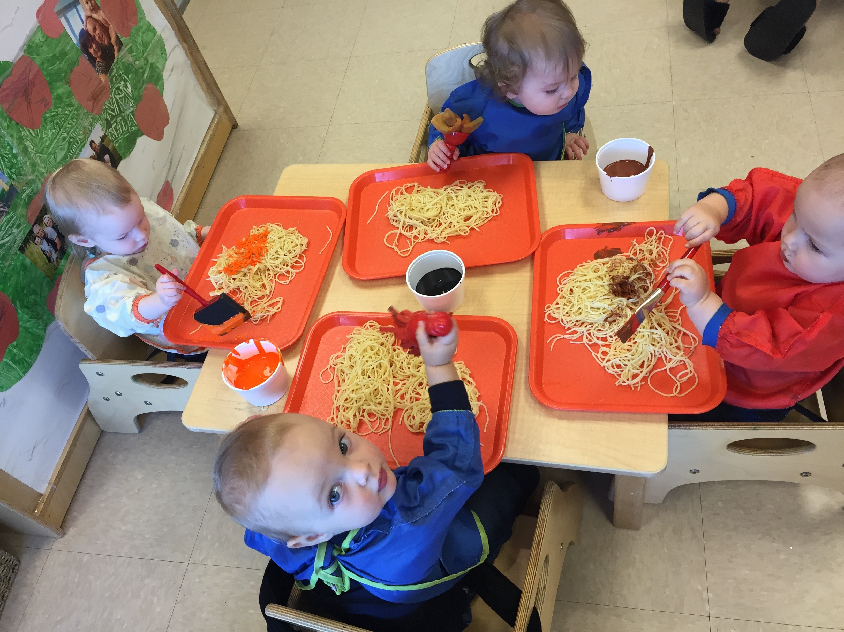

We have a new friend and his name is Emmett. Welcome to our new friend and family. Snow just arrived hopefully the babies will experience it. Dressing the babies in a snow pant, winter coats, boots, mittens and hats are going to be new in their routine and some babies will not like the feeling of additional clothing. We will explain to them the importance of wearing proper clothing before going outside so we are encouraging you our nursery mom and dad to help us by telling them also the same thing.
A lot of great activities are planned for October in preparation for the Halloween. Doing arts and crafts like; ghost, bats, zombie hand, candy footprint and a lot more. We will also decorate a pumpkin to make it a face and we also let them touch and feel the texture of the pumpkin seed. We will visit other room to show our cute little babies in their Halloween costume. So don’t forget to dress your child in their Halloween costume on October 31.
Developing their motor, language and social skill is always our priority. Encouraging them to do some things by themselves give them the feeling of being independent. It may be just a pair of words to you, but it's a full sentence to your toddler and a giant step forward in terms of language acquisition. If your child wants to help you around the house, come up with some simple tasks she/he can do.
Important dates to remember:
October 9 Thanks giving Daycare is closed.
October 31 Halloween dress your child.
