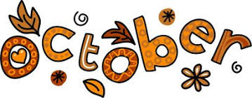
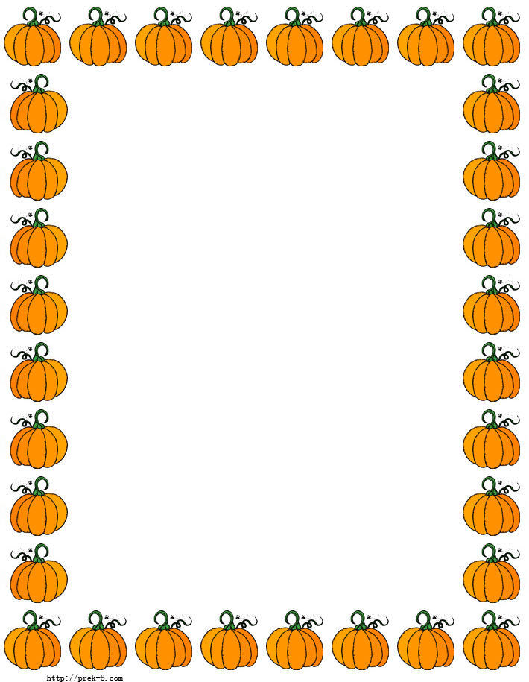

It’s hard to believe it’s already October! The kids have had an awesome first month getting back into the swing of things, starting school and a new routine. Firstly we want to thank the parents for being so cooperative with us while we have been re-vamping Preschool. We are so happy with the changes that have been made, and we hope you are too!

For Twin Day on October 20th, we will talk to your children and send out a master list of who your child chose to be twins with. We will also ask your children what they want to wear/ how they want their hair done in order to be matching. Once these lists are made up we will send them out via email and post them in the room. It will be such a fun day!
Some things to remember:
Lunches should have at least one item from each food group, this ensures that your child is given the opportunity to make healthy choices at lunchtime.
The weather is changing, please ensure your child has appropriate outside gear for fall weather.
Also try to ensure your child has a water bottle each day.

Important Dates:
October 6th - Thanksgiving party! - Happy 4th Birthday Emily L!
October 9th – CENTRE CLOSED, Happy Thanksgiving!
October 13th – Teddy Bear Picnic
October 15th – Happy 4th Birthday Lukas!
October 20th – Twin Day!
October 27th – PJ / Movie Day!

