OSC Newsletter – October 2017

Current Interest: Sports

Join our Facebook group (Seeds & Sprouts OSC) for reminders and updates on the children’s activities.

The first month of school has flown by. The children have settled back into the routine nicely. We have recently noticed a change in the children’s main interest. As they have all started going back to their after school activities they seem to be more interested in sports again. We plan on exploring different sports that are popular around the world and giving a few of them a try.

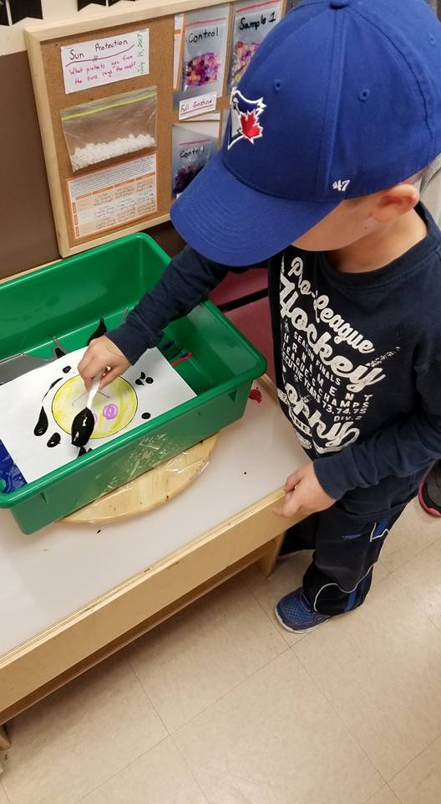
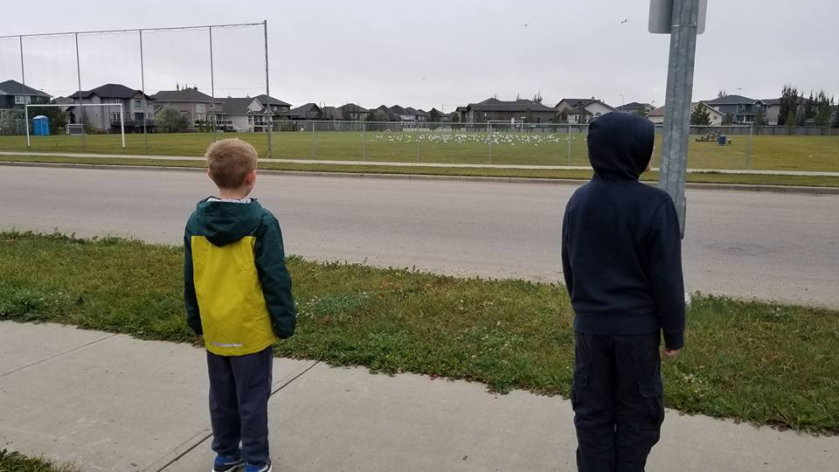
This month we have some fun Halloween activities planned. We’re going to have a Halloween themed movie & PJ party on October 20th, when the children don’t have school. On Halloween the children will get the chance to show off their costumes with our Halloween party after school. There will be lots of fun activities throughout the centre so we hope that everyone can make it out.

As always if you have any questions or concerns please feel free to come and talk to the room staff. Hope everyone has a super spooky Halloween!
Important Dates

4th – Early Dismissal
(BlackGold ONLY)
9th – DAYCARE CLOSED
Thanksgiving
20th – No School
Halloween Movie & PJ Party
31st – Halloween Party
3:30 – 5:00

