September was a great month full of adventure!
We had a blast on our field trip to the local fire hall. Each of us got to ride in the front seat of the fire truck; Firefighter Mike even put on all of his equipment for us to see! It was so much fun!
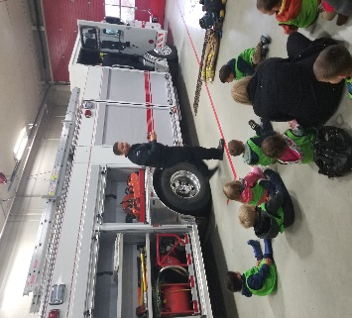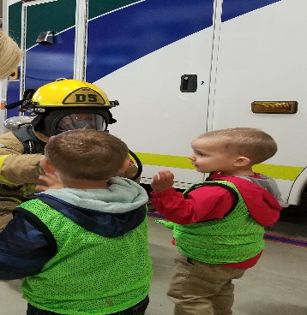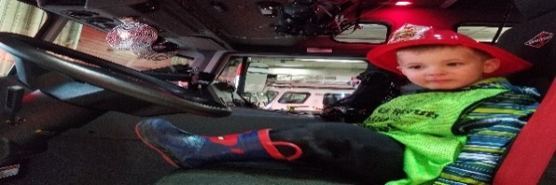
After the Fire Hall, we stopped for Timbits on our way back to the daycare! We loved this!
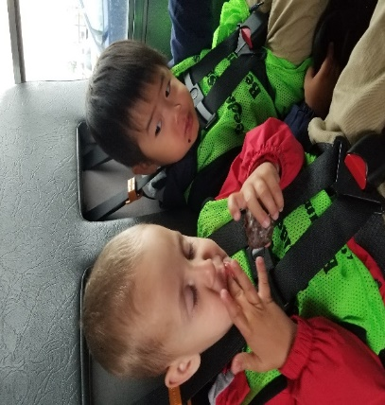
Are you going to finish that?

Friendly Reminders:
With the weather getting colder, please make sure your child has the following items at daycare:
- Mittens
- Toque
- Socks
- Jacket
- Splash Pants
- Boots
- And a change of clothes
It is important to remember to label all of your child’s items brought to the Daycare so we can get them back to the rightful homes.
This month, we have had lots of fun with sensory activities:
- We squished shaving cream between our fingers while looking for hidden critters.
- We scooped bubbles, played with sand and had a ton of fun with Play Dough!
- We also played with some feathers, Easter stuffing and butterfly’s in a bin while we learned about “things that fly”.
The group has also been hard at work during circle time working on our fine motor skills daily!
More Fun:
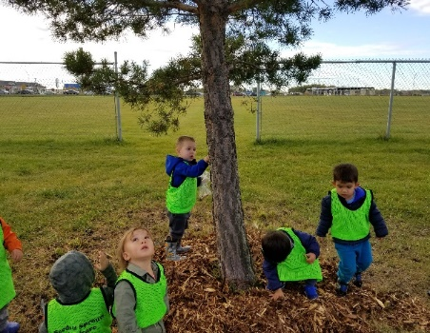
Through out the month we watched the leaves change from green to yellow to red on our morning adventures away from the facility.
The vibrant colours really sparked the Jr. Toddlers interest! Along with colors, the Jr. Toddlers expressed great attention in “things that fly”. We have read books about planes, talked about what we would see from a plane and what planes and birds have in common.
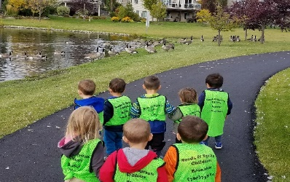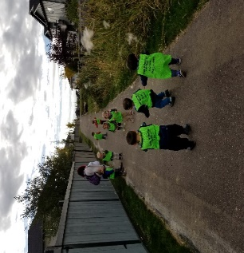
We have talked about wind and flying by chasing fluff as it blew in the wind. On one of our adventures we watched a family of geese closely as they enjoyed there afternoon bath!
The children love to point out the geese as they are flying high in the Sky!
For the month of October, we will continue to practice our colours and alphabets! Please watch closely for “Colour Clothing Days!”
- As part of our weekly activities, we have planned a fun day for each week (Friday), where we welcome the children to bring their toys from home, so we can work on sharing our interests and enjoyment.
We ask kindly that they remain at home for the rest of the week.
- We also ask that during drop off times, the children are dropped off as quickly as possible. This was they get to interacting with what we are doing in the class room and get the full experience!

We have so much fun here with our friends, learning new things each and every day! We are so excited to see what October has in store of us!

